**上海科技大学物质科学与技术学院**

**本科生科研项目总结报告**

**学 号**

**姓 名**

**专 业**

**入学年月**

**题 目**

**学分认定 □1 □2 □3 □4 学分**

**导师签字**

**年 月 日**

**炮钢材料XXXX**

火炮身管由较高强度与韧性的炮钢制造而成。炮钢材料及加工制造技术的发展，大幅提高火炮威力、减轻火炮质量、延长火炮使用寿命、降低生产成本。现代坦克炮、榴弹炮等大口径火炮的不断发展，对炮钢材料的研究和制备提出更高的挑战。作者综述了大口径厚壁炮钢的发展历程及性能，论述了炮钢材料的发展方向，提出炮钢材料发展的新思路。

随着火炮膛压的不断提高，中强度2%NiCrMoV钢逐渐不能胜任高膛压厚壁炮管材料，70年代以后，在世界范围内，大口径厚壁炮管，如105、155、175 mm等大炮身管大多采用3%Ni系列的Cr-Ni-Mo-V钢，如表11所示。

**表1. 炮钢化学成[1]**

|  |  |  |  |  |
| --- | --- | --- | --- | --- |
| 钢号(种) | C | Cr | Ni | Mo |
| A723 1级 | 0.35 | 0.80~2.00 | 1.50~2.25 | 0.2~0.4 |
| A723 2级 | 0.40 | 0.80~2.00 | 2.30~3.30 | 0.3~0.5 |
| A723 3级 | 0.40 | 0.80~2.00 | 3.30~4.50 | 0.4~0.8 |

The saturation loading of Pu(IV) in the membrane samples was ascertained by keeping an excess amount of Pu(IV) as observed from the measurements performed on remaining Pu concentration in solution after equilibration with the membrane2-4,7. The Pu(IV)-loading capacities are direct representative of the available binding sites (phosphate and sulphonate groups), and hence correlated to the amount of bifunctional polymer in the PES membranes1,4. It is seen from [Table 1](https://www.sciencedirect.com/science/article/pii/S0003267015005565" \l "tbl0005) that the Pu(IV)-loading capacity of the bifunctional layer grafted on a membrane is highly dependent on morphology of the surface of membrane3-5.

**Table 1. Pu(IV) loading capacity of the bifunctional layer grafted on a surface of the PES membranes having different pore sizes.**

|  |  |  |
| --- | --- | --- |
| Pore size (μm) | Pu loading capacity (μg) | |
|  | Rough side | Glossy side |
| 0.1 | 2.56 ± 0.06 | 1.83 ± 0.08 |
| 0.2 | 1.79 ± 0.09 | 1.08 ± 0.10 |

试验钢的非金属夹杂物等级达到：A0、B0、C0、D0.5、DS0，高的纯净度保证钢的综合力学性能1,4。

图2为试验炮钢经淬火高温回火后组织的TEM形貌。可以看到，显著细化的马氏体板条，板条间有细小的碳化物析出，使炮钢得到强化。

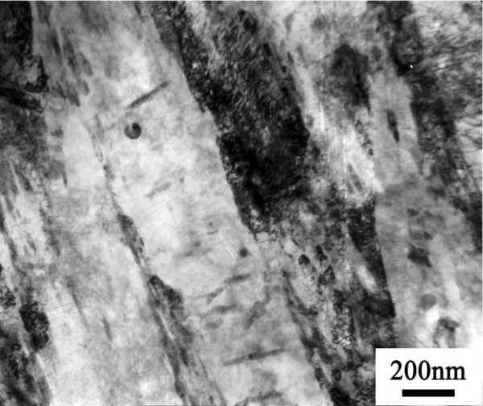

**图2. 新型炮钢的TEM图**

The typical alpha spectra obtained from the HEMP–AMPS membrane samples prepared by loading Pu from the unspiked and 238Pu spiked dissolver solutions are shown in [Fig. 2](https://www.sciencedirect.com/science/article/pii/S0003267015005565" \l "fig0030).In isotope dilution-alpha spectrometry (IDAS), Pu concentration in a given sample is determined from the change in 238Pu/(239Pu + 240Pu) alpha activity ratio of the sample with respect to the same in a mixture of the sample and the spike solution.

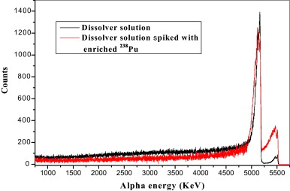

**Fig. 2. Alpha spectra obtained from the HEMP–AMPS grafted on glossy surface of PES membrane loaded with Pu(IV) ions form the un-spiked and spiked dissolver solutions.**

炮钢的韧性随着强度的提高而下降，目前厚壁炮钢的屈服强度从897 MPa提高到1173 MPa，冲击韧性下降一半，-40 ℃冲击功只有20 J 6-8,12，如何在继续提高炮钢强度的同时保证钢的韧性？高纯净度是炮钢获得良好综合性能的前提，但是获得高纯净度，对冶金设备、工艺提出了更高的要求，同时生产成本也会大幅增加3-5。

 (1)

**参考文献**

1. A. H. MacDonald, P. Schiffer, N. Samarth, *Nat. Mater.* **2005**, 4, 195.